The Giro delle Dolomiti, a fixed annual date for every cycling enthusiast

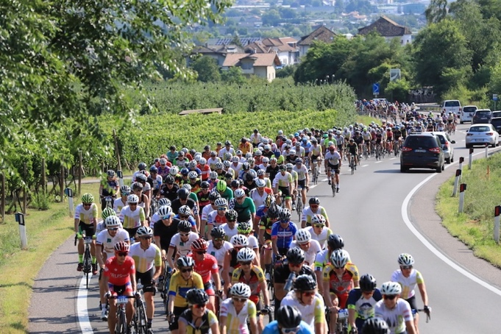
What makes the Giro delle Dolomiti so unique?
The Giro delle Dolomiti is a one-week cycling event for everyone that has taken participants - no active professionals! - through South Tyrol on their racing bikes in six stages (and one rest day) since its first edition in 1955. A main feature of the Giro delle Dolomiti is the combination of exercise on traffic-free roads and pleasure biking rounded off by high quality local products in an informal atmosphere. This firmly differentiates the Dolomites tour from the majority of other events. Every stage includes timed sections of a few kilometres (mountain time trials), which gives the Giro delle Dolomiti a competitive character. New in this year’s edition are four additional stages, the Giro Sprints. These are 2 kilometres long and not very steep. The organisers’ aim is to strengthen the sporting character of the tour while accommodating cyclists who may find the terrain more difficult. However, the main parts of the individual sections are cycled in groups at a controlled speed. It’s ideal for chats and swapping stories with other cyclists from over 30 different countries and from all continents - and of course to soak up the beauty of South Tyrol with all the senses.

When does the Giro delle Dolomiti 2021 take place?
For decades, the Giro delle Dolomiti has been taking place at the end of July. The 44th edition of the Giro delle Dolomiti will take place from Sunday, 25 July to Saturday, 31 July. After the first three stages, Wednesday, 28 July is a designated day of rest.

Where does the Giro delle Dolomiti 2021 go to?
The 44th edition of the Giro delle Dolomiti takes the participants into the paradise of Mendola, to Alpe di Siusi and, for the first time in 43-years long history of the circular tour, to the Brenta Dolomites (Lago Molveno, Madonna di Campiglio). The Giro delle Dolomiti also includes a loop around the whole of the Sella group, runs into the Catinaccio area and concludes, like the last years, with the team time trial in Bassa Atesina. The participants cover a total of 670 kilometres and over 12,000 metres of ascent. There is something for every taste and every level of difficulty. At the end of the Giro week, the participants will have experienced the whole of South Tyrol. The stages vary every year, while always including some of the classics.

Do participants have to complete all stages?
Around 80 percent of cyclists complete all six stages and are entered into the overall ranking. It is, however, also possible to buy start tickets for individual legs only.

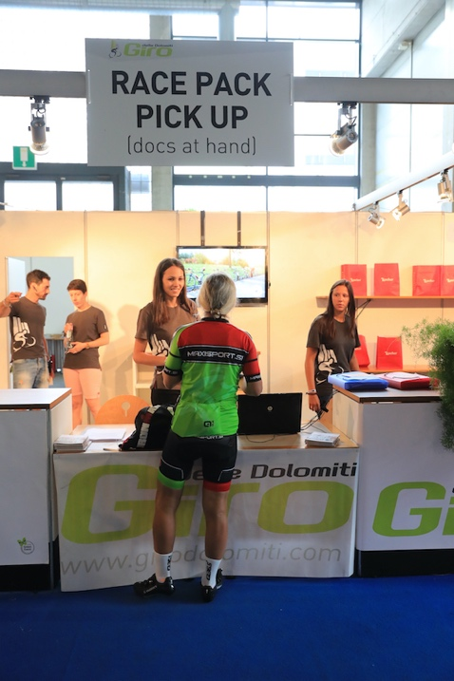
Where do the stages start?
The logistics "home base" of the Giro delle Dolomiti is at Fiera Bolzano. Five of the total of six stages start here; the third stage begins at Mezzocorona. Logistics are all taken care of.

What requirements are there of the participants in the Giro delle Dolomiti?
Well-trained legs and a good mood, as well as a medical certificate are really the only requirements. The Corona pandemic related safety measures will be communicated to the participants in due time according to the current developments.
The rest, such as safety and catering along the tour, is down to the around 60 highly motivated volunteers of the organising team, that stands for quality and dedication, and promises largely traffic-free roads.

The Giro delle Dolomiti concludes with a team time trial. What is it?
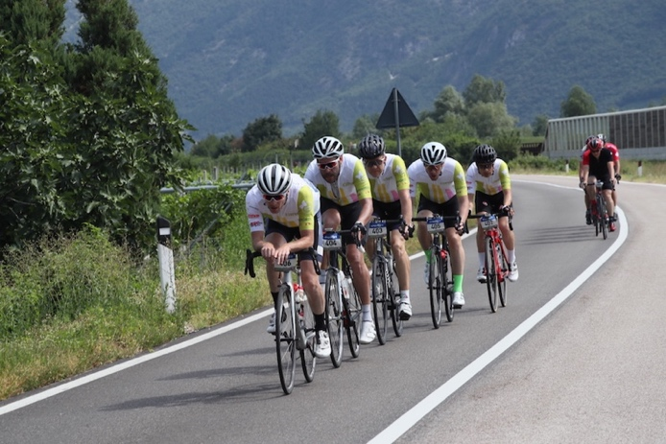
The individual cyclists of the Giro delle Dolomiti can form a team with other cyclists during the week. Teams must consist of a minimum of four and a maximum of five cyclists. They can also race the team time trial on their own. The time trial is timed and ranked, but the time is not included in the overall ranking of the individual participants. It is the crowning routine of an unforgettable week that is so useful for networking, and that permits not quite so strong mountain cyclists to achieve top results. As always - fun and entertainment are what matters most at the Giro delle Dolomiti.

What does participation in the Giro delle Dolomiti cost?
A weekly ticket costs 390 Euro, individual stages can also be booked for 80 Euro each. The fee includes lunch, several refreshment stops, timing, roadblocks, technical and traffic support, a jersey, free massages and much more.

Where can one register?
Registrations for the Giro delle Dolomiti can be made at https://www.girodolomiti.com/de/anmelden/.

More information on the stages of the 44th Giro delle Dolomiti:

Stage 1 - 1 Mendola paradise powered by Marlene (Sunday, 25 July)
Length: 90.8 km
Elevation gain: 1659 m
Timed section: 11.7 km/523 m elevation

Stage 2 - Alpe di Siusi powered by Alpe di Siusi (Monday, 26 July)
Length: 96.8 km
Elevation gain: 2213 m
Timed section: 11 km/714 m elevation
Giro Sprint: 2 km/186 m elevation

Stage 3 - Dolomiti del Brenta powered by Sportler (Tuesday, 27 July)
Length: 145.4 km
Elevation gain: 2521 m
Timed section: 8.3 km/456 m elevation
Giro Sprint: 2.0 km/124 m elevation

Stage 4 - Sellaronda powered by Q36.5 (Thursday, 29 July)
Length: 160.4 km
Elevation gain: 3306 m
Timed section 1: 5.5 km/236 m elevation
Timed section 2: 4.4 km/269 m elevation

Stage 5 - Catinaccio powered by Cofidis (Friday, 30 July)
Length: 89.6 km
Elevation gain: 2208 m
Timed section: 13.2 km/625 m elevation
Giro Sprint: 2 km/184 m elevation

Stage 6 - Team Crono Bassa Atesina powered by Alperia (Saturday, 31 July)
Length: 85.7 km
Elevation gain: 402 m
Timed section: 15.7 km/22 m elevation
Giro Sprint: 2 km/121 m elevation

Total kilometres: 670 km/12,270 m elevation
Total timed mountain cycling 69.8 km/2845 m elevation
Total kilometres Giro Sprint 8 km/615 m elevation

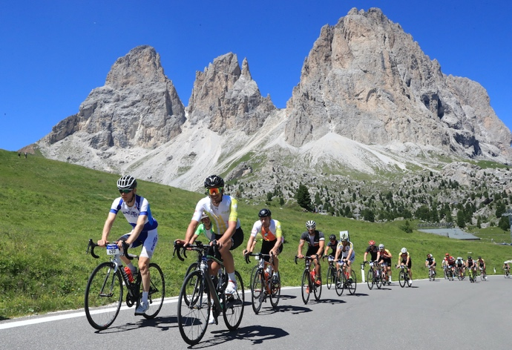
Contact and information:

Organizer:
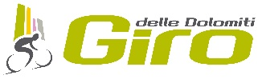
ASD Giro delle Dolomiti
Via Trieste 17/D
39100 Bolzano (BZ)
girodol@girodolomiti.com
(+39) 0471 1701188

Press office:

Hannes Kröss
@| hannes@hkmedia.bz
M| +39 333 7223248

W| www.hkmedia.bz

